**Documentation of the Project:**

1. **Data Acquisition:** The project involved receiving data in CSV format, each category separated into different files such as categories, customers, orders, products, shippers, suppliers, and employees. Additionally, the data was provided in SQL format. Initially, the CSV files were uploaded into a SQL database, and data extraction was performed based on specific queries.
2. **Excel Visualization:** After uploading the data into the SQL database, it was exported to Excel. Visualizations were then created in Excel based on the extracted data.
3. **Integration with Power BI:** Furthermore, the SQL database was connected to Power BI. Data transformation was carried out according to specific queries, and key performance indicators (KPIs) and metrics were computed. An overview of the visuals was provided to efficiently extract insights from the data.

This documentation outlines the process of importing data from CSV files to SQL, creating Excel visuals, connecting the SQL database to Power BI, and deriving insights through visualization and data analysis.

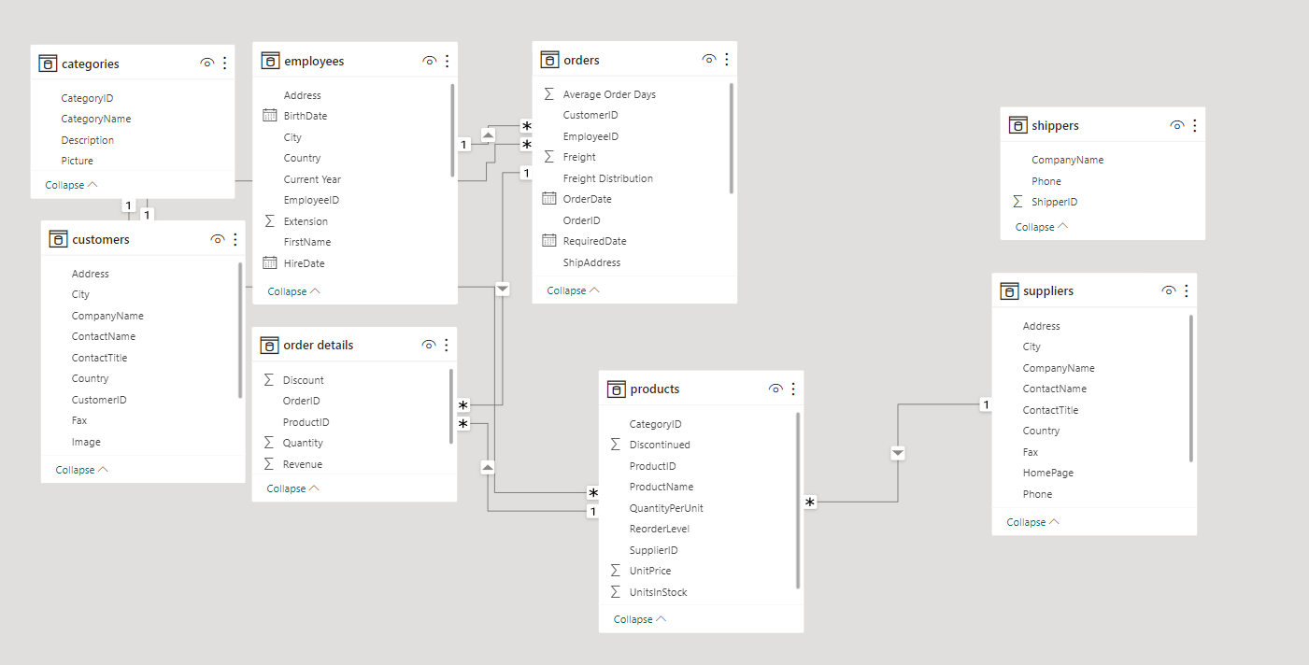

**Order History:**  
Frequency of orders: Customers who make regular purchases are likely more loyal.  
Order value: Higher-value orders might indicate stronger loyalty.  
Order dates: Patterns in ordering behavior could reveal seasonal trends or regular purchasing cycles.  
  
**Product Details:**Product popularity: Products frequently ordered by customers may contribute to retention.  
Product diversity: Offering a wide range of products might keep customers engaged.  
Product quality: Consistently delivering high-quality products can enhance loyalty. **Supplier Relationships:**Reliability of suppliers: Dependable suppliers ensure timely delivery and quality products.  
Supplier diversity: Working with multiple reliable suppliers can mitigate risks and maintain product availability  
  
**Employee Interactions:**Customer service quality: Positive interactions with employees may enhance customer satisfaction and loyalty.  
Employee engagement: Engaged and knowledgeable employees can provide better assistance, improving the overall customer experience.  
  
**Discounts and Promotions:**Effectiveness of discounts: Analyzing the impact of discounts on customer retention.  
Frequency of promotions: Regular promotions may incentivize repeat purchases.  
  
  
**Shipping and Logistics:**  
Timeliness of delivery: Prompt shipping can improve customer satisfaction and retention.  
Shipping options: Offering flexible shipping options might cater to different customer preferences.  
  
**Customer Demographics:**Geographic location: Regional preferences and trends may influence purchasing behavior.  
Customer segment analysis: Identifying key customer segments with higher retention rates.  
  
**Customer Feedback:**Reviews and feedback: Monitoring customer feedback to address concerns and improve satisfaction.  
Net Promoter Score (NPS): Measuring customer likelihood to recommend the brand to others.